**Task 9: Create a custom docker image for nginx and deploy it using docker compose, where the volume should be at /var/opt/nginx location. Push the created custom docker image to your docker-hub.**

1. **Custom nginx docker image:**

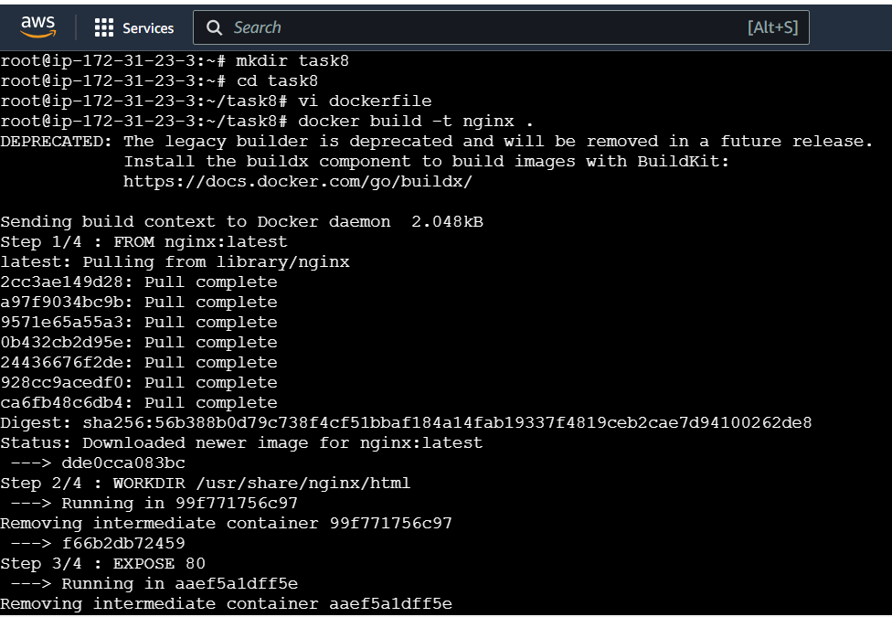

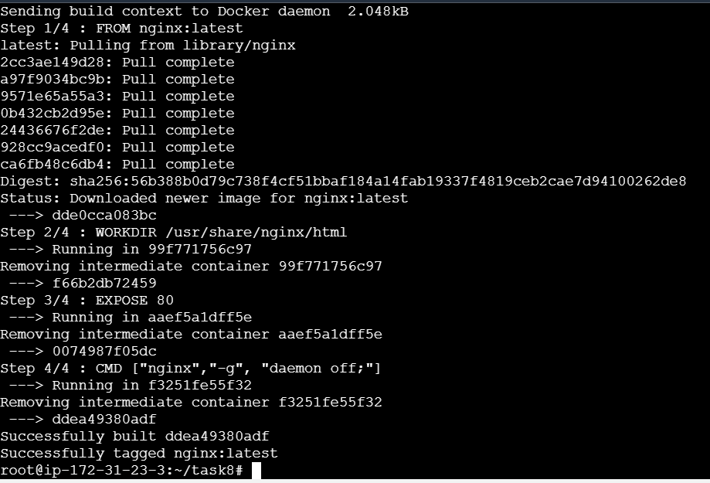

1. Docker images:

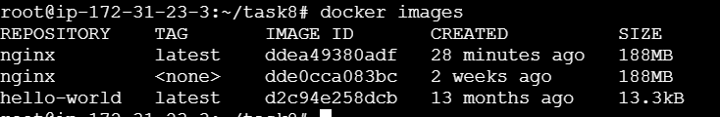

1. Docker compose file:

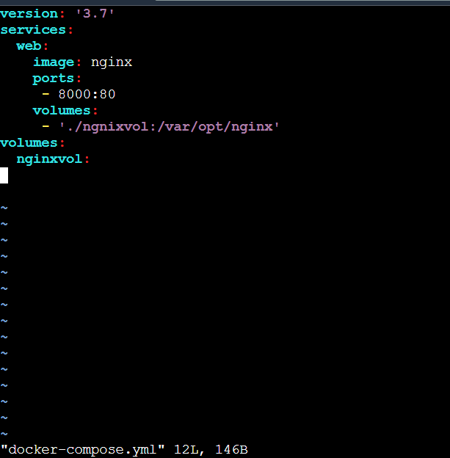

1. Volume created in the name ngnixvol:

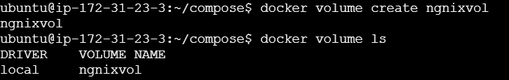

1. Execute the docker compose file and push it in docker hub:

